Treatment options for Base Narrow Canine Teeth with Palatal Contact
The options will vary depending on the alignment of the upper and lower jaws and if the lower canines are located in front of the upper canines and just need outward angulation (photo below)
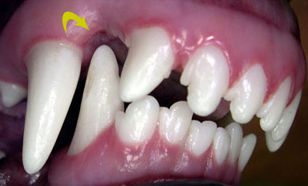
Or if there is a short lower jaw (Class II malocclusion) with the lower canines “trapped” along the inside (palatal aspect) of the upper canines or even behind the lower canines in more extreme cases. (photo below).
True Class II cases with the lower canines trapped along the inside of the upper canines and palatal trauma present typically have crown shortening with pulp caps or extraction of the lower canines as the two options for treatment.
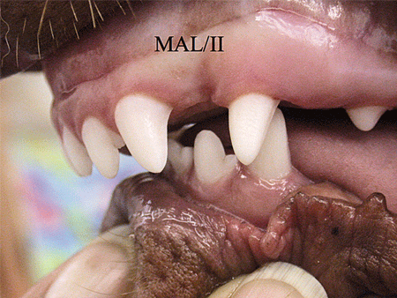
Ball Therapy: For mild cases where the lower canines need subtle outward movement and have a place to go (not class II cases), a rubber chew toy can be used to place outward orthodontic pressure on the lower canines. The ball needs to be properly sized to put the correct amount of pressure – too small and it will not contact the teeth, too large and it could actually push the canines downward instead of outward. There is a narrow window where this can work, so catching the lower canines as they are erupting and high enough to contact the ball is important. Ball play needs to happen as often as possible, at least 5-8 sessions lasting 10-15 minutes each day while trying to angle the teeth (typically 6 weeks).
Pros: Not invasive, easy to try
Cons: May not work
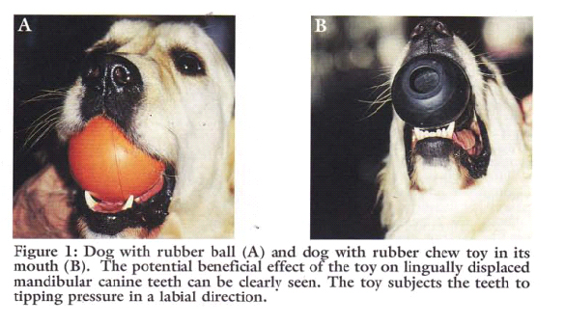

Incline plane: An orthodontic appliance is applied to both sides of the upper jaw along the premolars, canines, and incisors creating “ramps” that the lower canine teeth hit when the jaw is closed. The incline planes direct the lower canines outward into a more normal flared position (typically not class II bites unless we are trying to flare the lower canines BEHIND the uppers). The Incline planes need to be applied under general anesthesia and are typically left on for 4-8 weeks. The patient undergoes general anesthesia again when it is time for the incline planes to be removed and the teeth cleaned and polished. Outcomes are more uncertain with this procedure because of the complexity of orthodontic movement and variations with each case.
Pros: If it works, we keep the full height, structure, and function of the lower canine teeth.
Cons: Need to be very careful when the appliances are on and restrict chewing – no hard toys, treats, no playing with sticks/rocks in the yard, etc. as the composite can loosen or break off (if this happens, another episode of anesthesia is involved to repair the incline planes), they may not work = may not lead to proper movement even with a longer treatment time, the composite irritates the gingival and palatal tissue, the devices can only be used in select cases.
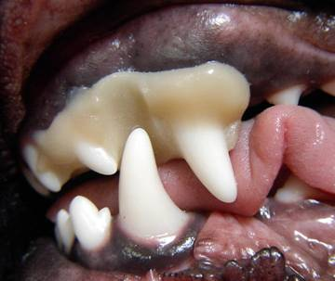

Surgical incline plane: For cases where the lower canines are almost in the correct position, but are impinging on the gingiva, that gingival tissue can be removed and shaped into a ramp using the dog’s owner gingival tissue. (not class II cases). Anesthesia is required to perform the procedure, and only a small amount of gingiva can be removed without exposing the underlying bone. If the procedure works, nor further follow up is needed. The gingiva needs to be kept clean with a rinse after the procedure, and it is sometimes combined with the ball therapy for extra outward movement.
Pros: Less restriction than with full orthodontic treatment, able to keep the lower canine intact
Cons: May not work or may need to be repeated once the initial site has healed, need to keep the site
During healing, can only be used in very select cases

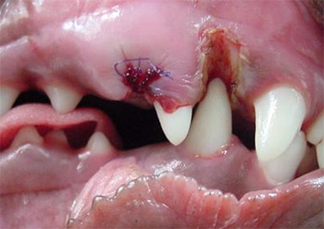
Composite extensions: Instead of ramps along the upper teeth, the lower canines can be built up with composite that angles outward and are longer to “catch” along the outside of the upper gingiva and create outward flare of the lower canine teeth (not class II cases). These extensions are applied under anesthesia, and then either removed fully or shortened after treatment again under anesthesia. The time-frame for active treatment with the extensions varies but is typically several weeks. Caution needs to be used so the dog does not chew on hard objects and chip or fracture off the composite. Because the composite is attached to the lower canine, it is also possible that the tooth itself could fracture. These are sometimes used on the lower canines as baby teeth to help create early movement in hopes the permanent teeth will follow suite. The extensions can only be used in select cases where more subtle movement is needed in dogs who are not aggressive/power chewers.
Pros: If it works, we retain the structure and function of the lower canine teeth.
Cons: Can only be used in select cases, composite can fracture off and the underlying canine tooth could
Damaged and fracture as well, may not work.

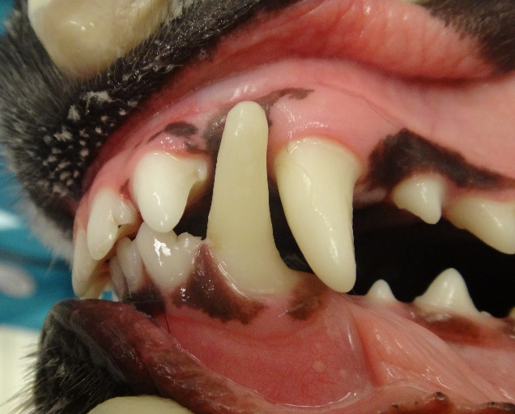
n

Crown Shortening of the lower canine with a pulp cap: In cases where the lower canine is trapped along the inside of the upper canine causing trauma, shortening of the lower canine can be performed to retain some structure and function of the lower canine without further damage to the roof of the mouth. Because the canine tooth’s height is reduced to the point where the pulp is exposed, a dressing needs to be placed on the pulp to protect it and try and keep the tooth vital (alive). The tooth is then restored with composite that matches the tooth color and is very strong. The success rate of this procedure with current materials is 92%. Follow up is needed to radiograph the tooth to be sure it is maturing normally, and this is usually done at 6-12 months post procedure. Because the tooth is shorter, risk of fracture is lower but the composite needs to be checked on regular basis because it can be damaged in powerful chewers. If the procedure were to fail, a root canal or extraction would be needed. This is often my preferred treatment choice in true class II cases over surgical extraction/s of the lower canine teeth.
Pros: Less invasive than extraction with ability to preserve the canine root and provide strength to the
lower jaw
Cons: Potential for procedure failure (low), need for follow up, potential for damage to composite or
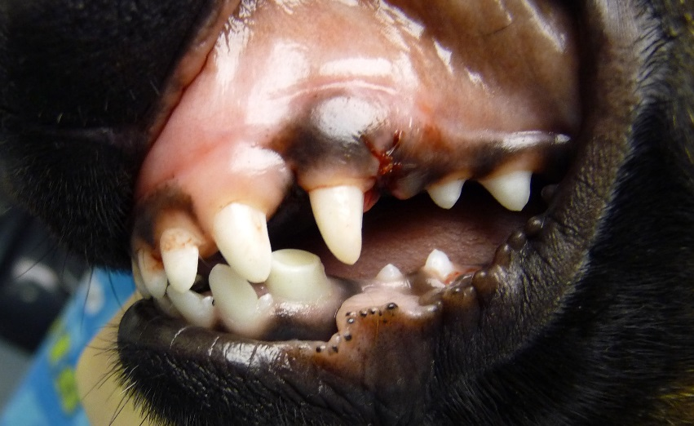
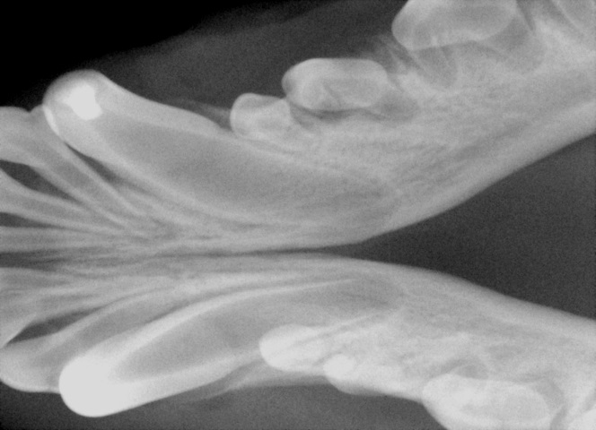
fracture of the tooth

Surgical extraction of lower canine teeth: Extraction of the lower canine teeth can be considered to prevent ongoing palatal trauma in cases where there is concern for future follow up or complications. The lower canine teeth in dogs have extremely long roots that do contribute strength to the lower jaws. This is a complicated, surgical extraction that needs to be performed with care and using dental radiographs to check the sites both pre and post extraction. Potential complications are jaw fracture, infection, bleeding, non-healing of the extraction site, and dehiscence or falling apart of the surgical flap. There is a 4 week healing period where hard chewing needs to be avoided and sometimes the patient needs to wear an e-collar to prevent pawing or rubbing at the face. Sometimes bone graft is placed in the lower extraction sites to help the body lay down healing bone more rapidly. There can also be tongue loll (flopping of the tongue over the teeth and out the side of the mouth) after extraction of the lower canines and sometimes more drool pooling in the lip margin.
Pros: Considered more of a “one and done” procedure with less long-term follow up if the surgery and
healing go well.
Cons: Invasive surgery, potential for surgical complications during procedure and healing period,
weakening of the lower jaw bone by removing roots
